Open ID Connect (OIDC) client Reference Guide

This reference guide helps you to use the OIDC Client to test or work with your Open ID Connect Provider. The details of each control has been provided in this document.

Prerequisites:
- You should first register your application at Open ID Connect Provider.
- Following redirect URL should be used while registration:
https://oidcclient.gslab.com:8443/OIDCClient/startOAuth/_callback
This is standard redirect URL to be used for all registrations you do at different Open ID Connect Providers.

Procedure:
- Once you’re done with registration at Open ID Connect Provider, start the OIDC Client using following URL:
http://oidcclient.gslab.com:8443/OIDCClient
- Once the home page is loaded, click on the configuration button on right upper corner of the page.
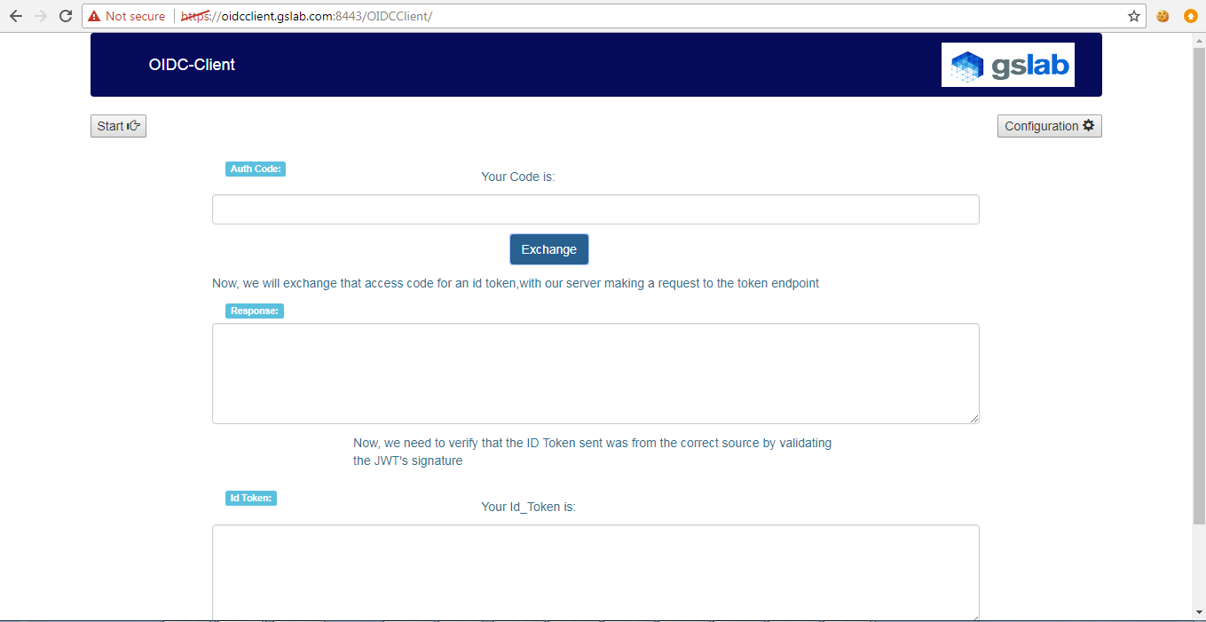
- Configuration details form will be shown as below.
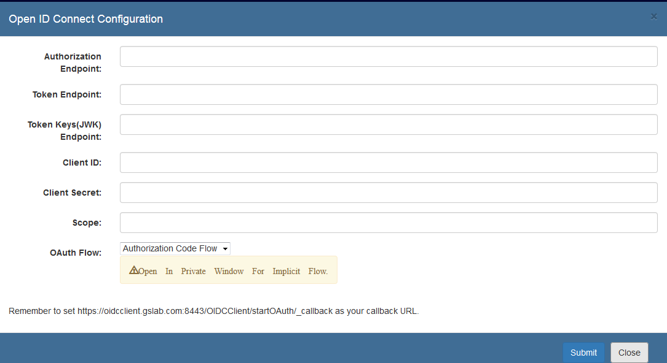
- Following are the details of the each field shown in the configuration form:
  - Authorization End Point: It’s provided by your Open ID Connect Provider and is responsible for authentication, authorization. It’s also used to generate token in case of “Implicit Flow”.
  - Token End Point: It’s provided by your Open ID Connect Provider and is responsible for issuing tokens (id_token, access_token, etc.).
  - JWK URL: It’s provided by your Open ID Connect Provider and is responsible for providing the JSON Web keys which will be used to validate the id_token.
  - Client ID: It’s unique key provided by your Open ID Connect Provider after registration.
  - Client Secret: It’s secret key provided by your Open ID Connect Provider after registration.
  - OAuth Flow: We only provide 2 options here: “Authorization Code Flow” and “Implicit Flow”.
- Now, click on “Submit” button at the bottom of the form.
- Once the configuration details are submitted successfully, you’re ready to use the OIDC Client for working with your Open ID Connect Provider.
- Click on “Start” button on the left side of the page.
- Based on the configurations provided like Authorization End Point, OAuth Flow, you’ll be redirected to Authorization end point for authentication and authorization.
- Once you’re authenticated successfully, you’ll be asked to provide the consent for providing your user information and profile access to OIDC Client.
- Once you click “Allow”, you’ll be redirected back to OIDC Client home page.
- If you’d selected “Authorization Code Flow” in the OAuth Flow drop down configuration, you’ll get “Authorization Code” in the text box and for “Implicit Flow” option you’ll receive Auth response and id_token.
- If you’ve received “Authorization Code”, then you can simply click on “Exchange” button for issuing id_token from configured Token End point.
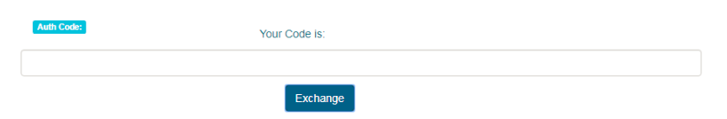
- Now, you’ll see Auth response and id_token.
- Once you see id_token, you can click on “Verify” button to verify the validity of it_token.
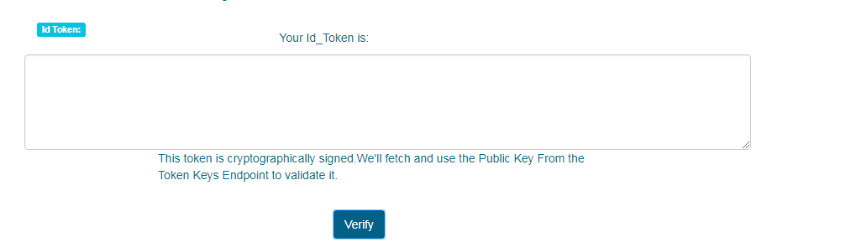
- If your id_token is valid you’ll see the header and payload part of the id_token.

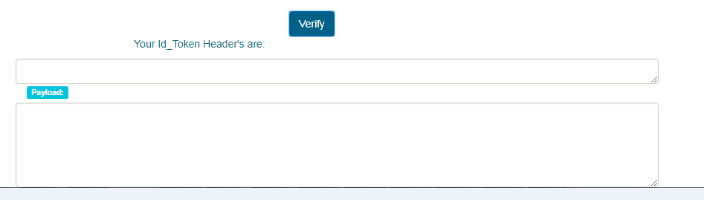
End of Document

